**Name of the experiment:**

**IOT GPS Tracker**

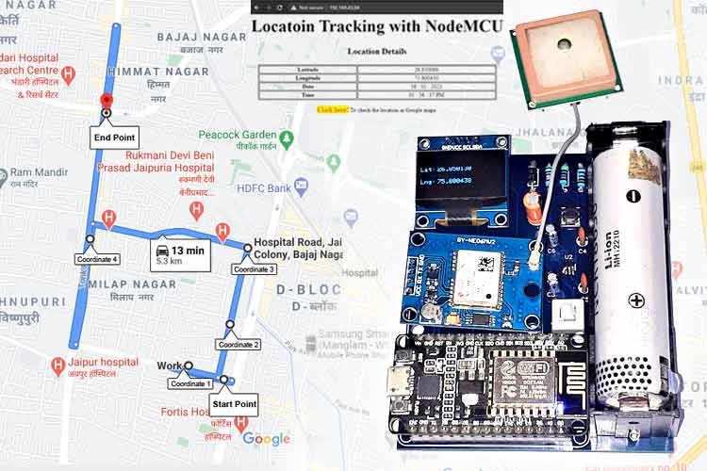

**Abstract:**

In this mini project we are going to design an IOT GPS Tracker. The need for it is that in the future there will be no toll gates in order to generate the road tax instead we will be having GPS Tracker in each & every car which calculates the fare on the distance you have travelled and the bill will be generated for that amount of kilometres.

Actually, the aim is to design the IOT GPS Tracker which tracks the latitude & longitude which will be pushed into a webserver via Wifi Module with the help of a Nodemcu ESP8266. There in the webserver we can plot the distance travelled on the google maps. We also use the OLED Module in order to display the current latitude & longitude of the exact location.

For this project the extension is that we need to program for which based on the no of kilometres the fare gets calculated.

**Components Required:**

1. Nodemcu ESP8266
2. NEO-6M GPS Module
3. OLED Display Module
4. FP6291 Boost Converter IC
5. Resistors – 10KΩ,100KΩ,48KΩ
6. Capacitors – 0.1uF,10uF,20uF
7. Inductor – 4.7uH
8. Diode – 1N5388BRLG
9. 18650 Lithium Cell
10. 18650 Lithium Cell Holder
11. 6 Pin Push Button Switch
12. Breadboard
13. Jumper Wires

**Circuit Diagram:**

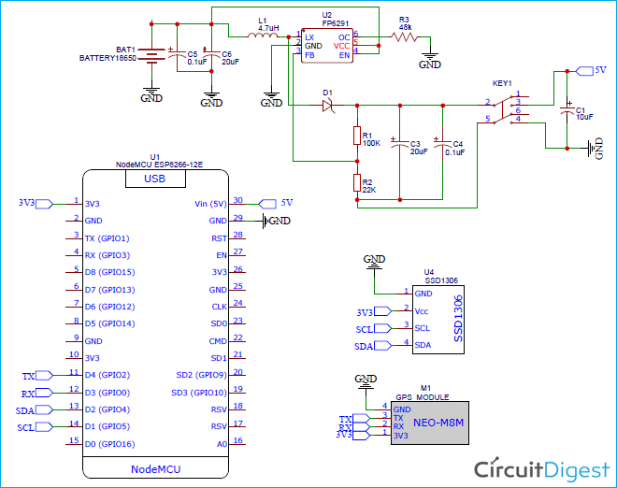

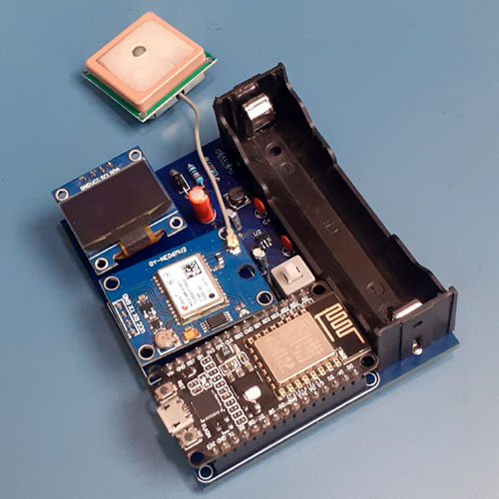

**Reference Links:**

* <https://youtu.be/gXK2vExOuxQ>
* [IoT Based GPS Location Tracker using NodeMCU and GPS Module – Save GPS co-ordinates and view on Google Maps (circuitdigest.com)](https://circuitdigest.com/microcontroller-projects/iot-based-gps-location-tracker-using-nodemcu-track-and-save-gps-location-on-google-maps)